**DATABASE MANAGEMENT SYSTEM**

PROJECT REPORT

ON

**HOTEL MANAGEMENT SYSTEM**

Submitted to-

Prof. Anika

By-

Chirag Mahawar 101603078

Navjot Singh Sandhu 101603199

COE-6

**ACKNOWLEDGEMENT**

We wish to express our sincere gratitude to Prof. Anika, Computer Science & Engineering Department, Thapar University, for providing us with an opportunity to undertake a Project on HOTEL MANAGEMENT SYSTEM.

We are grateful to Dr Anika for her valuable assistance and guidance throughout the project.

**CONTENTS**

* Requirement Analysis
* ER Diagram
* ER to Table Conversion
* Functional Dependence Diagram
* Finalised Tables
* PL/SQL Codes

**REQUIREMENT ANALYSIS**

A Hotel Management System would like to keep track on the guests residing in the hotel, Reservations made by them, payment done by them, room services (like food etc.) offered to guests in their rooms. Also it would like to maintain the database of all employees working in the hotel, their managers & services offered by them.

A hotel consists of many rooms. Each room has a room type (E.g. Presidential Suite, ordinary etc.), but each room type consists of many rooms. More than one room can be allotted to a single guest but vice-versa not true. A single guest can make multiple payments but one payment is done only by one guest. A guest can also make multiple reservations for multiple rooms. After this the guest is provided with room service. The room service can be offered by more than one employee. Every employee is managed by a manager which is also an employee. Many employees can be managed by one manager but only one manager heads one employee.

**ER DIAGRAM**

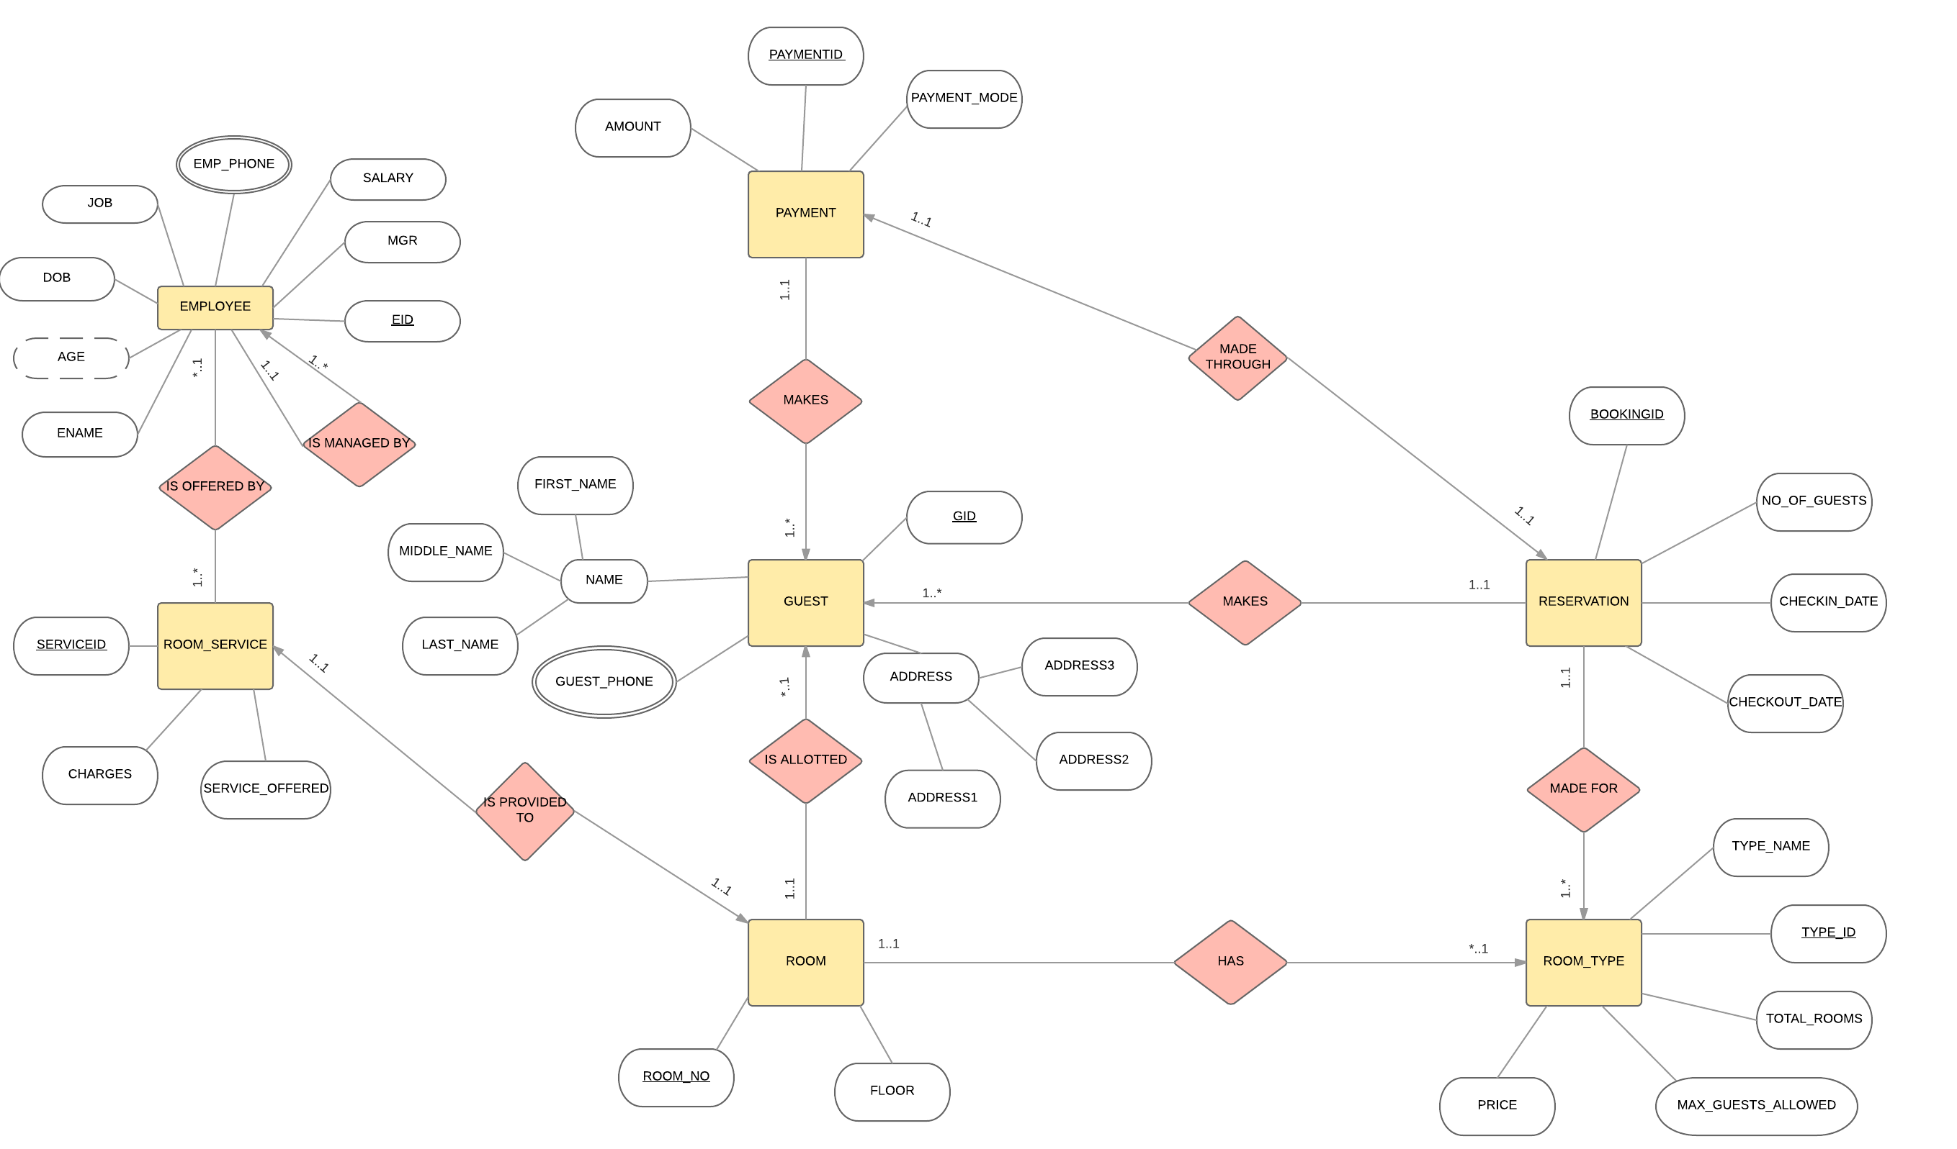

**ER TO TABLE CONVERSION**

Converting ER Diagram to Tables with proper care given to composite attributes, multi-valued attributes, Derived attributes & connectivity of relationships.

|  |  |  |
| --- | --- | --- |
| **Name** | **Null?** | **Type** |
| Type_id | NOT NULL | number(10) |
| Type_name |  | varchar2(30) |
| Total_Rooms |  | number(10) |
| Max_guests_allowed |  | number(10) |
| Price |  | number(10) |

**Room_Type**

**Payment**

|  |  |  |
| --- | --- | --- |
| **Name** | **Null?** | **Type** |
| Payment_id | NOT NULL | varchar2(10) |
| Payment_mode |  | varchar2(30) |
| Amount |  | number(10) |
| Booking_id |  | varchar2(10) |
| Gid |  | number(10) |

**Room_Service**

|  |  |  |
| --- | --- | --- |
| **Name** | **Null?** | **Type** |
| Service_id | NOT NULL | number(10) |
| Service_offered |  | varchar2(20) |
| Charges |  | number(10) |
| Eid |  | number(10) |
| Room_no |  | number(10) |

**Employee**

|  |  |  |
| --- | --- | --- |
| **Name** | **Null?** | **Type** |
| Eid | NOT NULL | number(10) |
| Ename | NOT NULL | varchar2(30) |
| Job |  | varchar2(30) |
| DOB |  | Date |
| Salary |  | number(10) |
| Mgr |  | number(10) |

**Guest**

|  |  |  |
| --- | --- | --- |
| **Name** | **Null?** | **Type** |
| Gid | NOT NULL | number(10) |
| First_name | NOT NULL | varchar2(15) |
| Middle_name |  | varchar2(15) |
| Last_name |  | varchar2(15) |
| Address 1 |  | varchar2(30) |
| Address 2 |  | varchar2(30) |
| Address 3 |  | varchar2(30) |

**Emp_Phone**

|  |  |  |
| --- | --- | --- |
| **Name** | **Null?** | **Type** |
| Eid |  | number(10) |
| Phone |  | number(15) |

**Guest_Phone**

|  |  |  |
| --- | --- | --- |
| **Name** | **Null?** | **Type** |
| Gid |  | number(10) |
| Phone |  | number(15) |

**Reservation**

|  |  |  |
| --- | --- | --- |
| **Name** | **Null?** | **Type** |
| Booking_id | NOT NULL | varchar2(10) |
| No_of_guests | NOT NULL | number(10) |
| CheckIn_date | NOT NULL | Timestamp |
| CheckOut_date | NOT NULL | Timestamp |
| Type_id |  | number(10) |
| Gid |  | number(10) |

**Room**

|  |  |  |
| --- | --- | --- |
| **Name** | **Null?** | **Type** |
| Room_no | NOT NULL | number(10) |
| Floor |  | number(10) |
| Gid |  | number(10) |
| Type_id |  | number(10) |

FUNCTIONAL DEPENDENCE DIAGRAM

**Reservation**

Type_id

Booking_id

CheckOut_date

CheckIn_date

No_of_Guests

Gid

**Room_Type**

Type_id

Price

Max_Guests_Allowed

Total_rooms

Type_name

**Room**

Room_no

Type_id

Gid

Floor

**Payment**

Payment_id

Gid

Booking_id

Amount

Payment_mode

**Room_Service**

Service_id

Eid

Room_no

Charges

Service_offered

**Employee**

Eid

Mgr

Salary

DOB

Job

Ename

**Guest**

Gid

Address3

Address2

Address1

Last_name

Middle_name

First_name

**Emp_Phone**

Phone

Eid

**Guest_Phone**

Phone

Gid

FINALISED TABLES

After Normalisation of tables we came up with the following tables.

**Room_Type**

|  |  |  |
| --- | --- | --- |
| **Name** | **Null?** | **Type** |
| Type_id | NOT NULL | number(10) |
| Type_name |  | varchar2(30) |
| Total_Rooms |  | number(10) |
| Max_guests_allowed |  | number(10) |
| Price |  | number(10) |

**CODE FOR ROOM_TYPE TABLE CREATION**

create table Room_Type(

Type_id number(10) constraint pk_Rt PRIMARY KEY,

Type_name varchar2(30) constraint nn_Rt NOT NULL,

Total_rooms number(10),

Max_Guests_Allowed number(10),

Price number(10)

);

**Room**

|  |  |  |
| --- | --- | --- |
| **Name** | **Null?** | **Type** |
| Room_no | NOT NULL | number(10) |
| Floor |  | number(10) |
| Gid |  | number(10) |
| Type_id |  | number(10) |

**CODE FOR ROOM TABLE CREATION**

create table Room(

Room_no number(10) constraint pk_R PRIMARY KEY,

Floor number(10),

Gid varchar2(10) references Guest(Gid),

Type_id number(10) references Room_Type(Type_id));

**Payment**

|  |  |  |
| --- | --- | --- |
| **Name** | **Null?** | **Type** |
| Payment_id | NOT NULL | varchar2(10) |
| Payment_mode |  | varchar2(30) |
| Amount |  | number(10) |
| Booking_id |  | varchar2(10) |
| Gid |  | number(10) |

**CODE FOR PAYMENT TABLE CREATION**

create table Payment(

Payment_id varchar2(10) constraint pk_P PRIMARY KEY,

Payment_mode varchar2(30) constraint check_P CHECK(Payment_mode IN('Credit Card','Debit Card','Cash','Online Banking')),

Amount number(10),

Booking_id varchar2(10) references R1(Booking_id),

Gid varchar2(10) references Guest(Gid));

**Room_Service**

|  |  |  |
| --- | --- | --- |
| **Name** | **Null?** | **Type** |
| Service_id | NOT NULL | number(10) |
| Service_offered |  | varchar2(20) |
| Charges |  | number(10) |
| Eid |  | number(10) |
| Room_no |  | number(10) |

**CODE FOR ROOM_SERVICE TABLE CREATION**

create table Room_Service(

Service_id number(10) constraint pk_Rs PRIMARY KEY,

Service_offered varchar2(20) constraint check_Rs CHECK(Service_offered IN('Laundry','Food Delivery','Room Service')),

Charges number(10),

Eid number(10) references Employee(Eid),

Room_no number(10) references Room(Room_no)

);

**Employee**

|  |  |  |
| --- | --- | --- |
| **Name** | **Null?** | **Type** |
| Eid | NOT NULL | number(10) |
| Ename | NOT NULL | varchar2(30) |
| Job |  | varchar2(30) |
| DOB |  | Date |
| Salary |  | number(10) |
| Mgr |  | number(10) |

**CODE FOR EMPLOYEE TABLE CREATION**

create table Employee(

Eid number(10) constraint pk_E PRIMARY KEY,

Ename varchar2(30) constraint nn_E NOT NULL,

Job varchar2(30) constraint check_E CHECK(Job IN('Manager','Laundrymen','Food Service','Janitor','Cook','Receptionist','Security')),

DOB date,

Salary number(10) CHECK(Salary>0),

Mgr number(10)

);

**Guest**

|  |  |  |
| --- | --- | --- |
| **Name** | **Null?** | **Type** |
| Gid | NOT NULL | number(10) |
| First_name | NOT NULL | varchar2(15) |
| Middle_name |  | varchar2(15) |
| Last_name |  | varchar2(15) |
| Address 1 |  | varchar2(30) |
| Address 2 |  | varchar2(30) |
| Address 3 |  | varchar2(30) |

**CODE FOR GUEST TABLE CREATION**

create table Guest(

Gid varchar2(10) constraint pk_R1 primary key ,

First_name varchar2(15) constraint nn_G NOT NULL,

Middle_name varchar2(15),

Last_name varchar2(15),

Address1 varchar2(30),

Address2 varchar2(30),

Address3 varchar2(30));

**Emp_Phone**

|  |  |  |
| --- | --- | --- |
| **Name** | **Null?** | **Type** |
| Eid |  | number(10) |
| Phone |  | number(15) |

**CODE FOR EMP_PHONE TABLE CREATION**

create table Emp_phone(

Eid number(10) constraint pk_EP primary key,

Phone number(15));

**Guest_Phone**

|  |  |  |
| --- | --- | --- |
| **Name** | **Null?** | **Type** |
| Gid |  | number(10) |
| Phone |  | number(15) |

**CODE FOR GUEST_PHONE TABLE CREATION**

create table Guest_phone(

Eid number(10) constraint pk_GP primary key,

Phone number(15));

As seen from the Reservation table FD Diagram, it contained transitive dependency & so in order to normalise the Reservation in 3NF it is decomposed in Reservation(R1,R2) as shown.

**R1**

|  |  |  |
| --- | --- | --- |
| **Name** | **Null?** | **Type** |
| Booking_id | NOT NULL | varchar2(10) |
| CheckIn_date | NOT NULL | Timestamp |
| CheckOut_date | NOT NULL | Timestamp |
| Type_id |  | number(10) |
| Gid |  | number(10) |
| Payment_id |  | varchar2(10) |

**CODE FOR R1 TABLE CREATION**

create table R1(

Booking_id varchar2(10) constraint pk_R1 primary key ,

Gid varchar2(10)references Guest(Gid),

CheckIn_date timestamp,

CheckOut_date timestamp,

Type_id number(10) references Room_Type(Type_id));

**R2**

|  |  |  |
| --- | --- | --- |
| **Name** | **Null?** | **Type** |
| Gid | NOT NULL | number(10) |
| NO_of_guests |  | number(10) |

**CODE FOR R2 TABLE CREATION**

create table R2(

Gid varchar2(10) constraint pk_R2 primary key,

No_of_guests number(10));

PL/SQL CODES

PL/SQL CODES FOR INSERTION OF DATA INTO TABLES

* **EMPLOYEE**

DECLARE

id number(10);

name varchar2(30);

job varchar2(30);

dob date;

salary number(10);

mgr number(10);

BEGIN

insert into Employee values(&id,'&name','&job','&dob',&salary,&mgr);

COMMIT;

END;

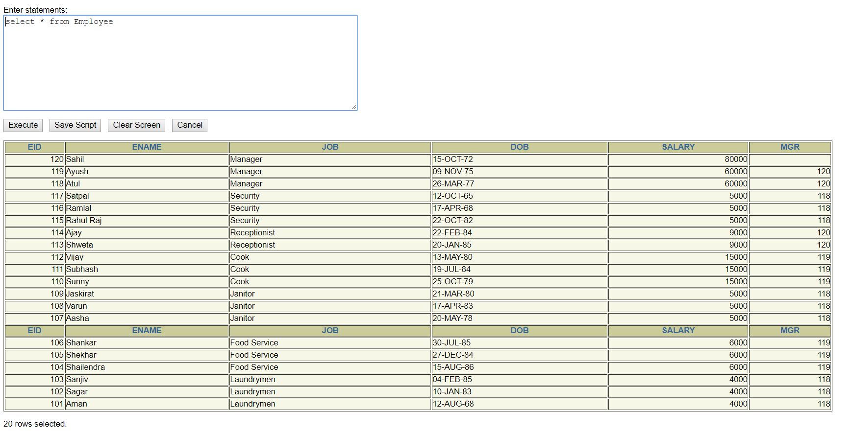

* **GUEST**

DECLARE

gid number(10);

f_name varchar2(15);

m_name varchar2(15);

l_name varchar2(15);

address1 varchar2(30);

address2 varchar2(30);

address3 varchar2(30);

BEGIN

insert into Guest values(&gid,'&f_name','&m_name','l_name','&address1','&address2','&address3');

COMMIT;

END;

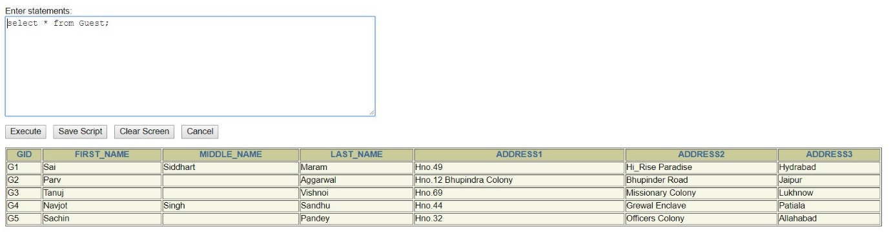

* **EMP_PHONE**

DECLARE

eid number(10);

phone number(15);

BEGIN

insert into Emp_phone values(&eid,&phone);

COMMIT;

END;

* **GUEST_PHONE**

DECLARE

gid number(10);

phone number(15);

BEGIN

insert into Guest_phone values(&gid,&phone);

COMMIT;

END;

* **ROOM_SERVICE**

DECLARE

id number(10);

service varchar2(20);

charges number(10);

eid number(10);

room_no number(10);

BEGIN

insert into Room_Service values(&id,'&service',&charges,&eid,&room_no);

COMMIT;

END;

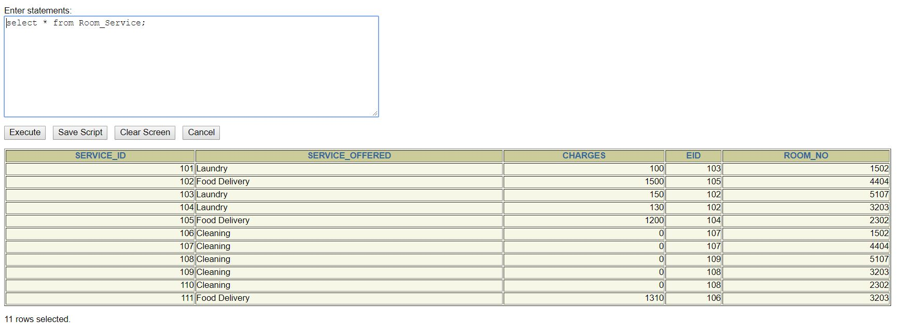

* **PAYMENT**

DECLARE

id varchar2(10);

mode varchar2(30);

amount number(10);

bid varchar2(10);

gid number(10);

BEGIN

insert into Payment values(&id,'&mode',&amount,&bid,&gid);

COMMIT;

END;

* **ROOM**

DECLARE

room_no number(10);

floor number(30);

gid number(10);

typeid number(10);

BEGIN

insert into Room values(&room_no,&floor,&gid,&typeid);

COMMIT:

END;

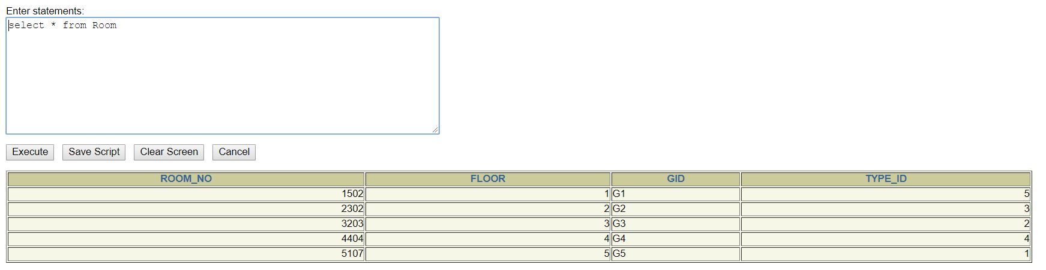

* **ROOM_TYPE**

DECLARE

typeid number(10);

typename varchar2(30);

total_rooms number(10);

max_guests number(10);

price number(10);

BEGIN

insert into Room_Type values(&typeid,'&typename',&total_rooms,&max_guests,&price);

COMMIT;

END;

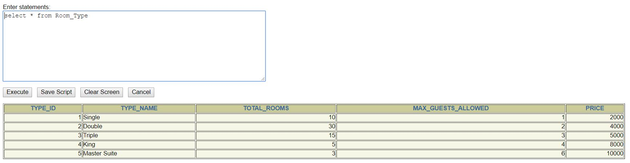

* **R1**

DECLARE

id varchar2(10);

checkin timestamp;

checkout timestamp;

typeid number(10);

gid number(10);

BEGIN

insert into R1 values(&id,'&checkin','&checkout',&typeid,&gid);

COMMIT;

END;

* **R2**

DECLARE

id varchar2(10);

no_of_guests number(10);

BEGIN

insert into R2 values(&id,&no_of_guests);

COMMIT;

END;

STORED FUNCTION TO DISPLAY GRADE OF EMPLOYEE USING CURSOR & CONDITIONAL CONTROL

CREATE OR REPLACE FUNCTION Find_Grade RETURN NUMBER IS

Grade varchar2(10);

CURSOR c_emp IS select * from Employee;

invalid_salary EXCEPTION;

BEGIN

FOR item in c_emp

LOOP

IF item.Salary<0 THEN

RAISE invalid_salary;

ELSIF item.Salary>70000 THEN

Grade:='A';

ELSIF item.Salary BETWEEN 50000 AND 70000 THEN

Grade:='B';

ELSIF item.Salary BETWEEN 20000 AND 50000 THEN

Grade:='C';

ELSIF item.Salary BETWEEN 10000 AND 20000 THEN

Grade:='D';

ELSE

Grade:='E';

END IF;

DBMS_OUTPUT.PUT_LINE('Grade of '||item.Eid||' , '||item.Ename||' is - '||grade);

END LOOP;

EXCEPTION

WHEN invalid_salary THEN

DBMS_OUTPUT.PUT_LINE('Salary of Employee is invalid. Please see the Employees Database.');

RETURN 0;

END;

PL/SQL CODE TO CALL Find_Grade FUNCTION

set serveroutput on;

set verify off;

DECLARE

n NUMBER;

BEGIN

n:=Find_Grade;

END;

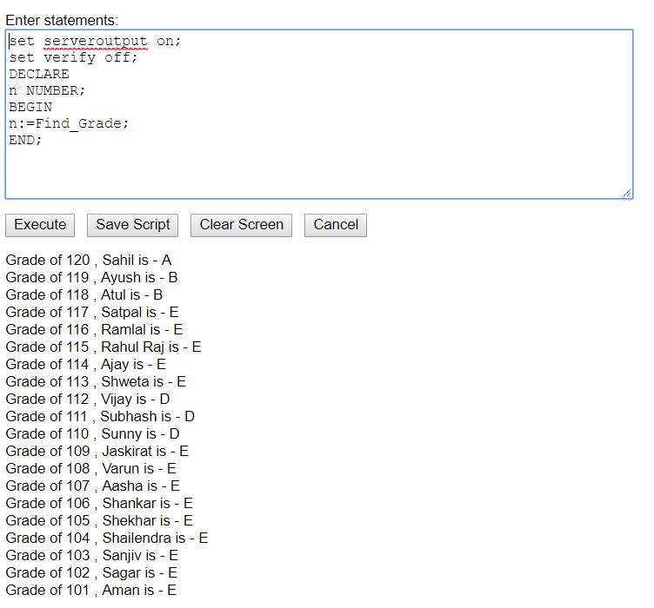

STORED PROCEDURE TO CALCULATE TOTAL AMOUNT PAYABLE FOR A GUEST

CREATE OR REPLACE PROCEDURE Find_Bill

(gid1 IN varchar2,amt OUT number) IS

price number(10);

charges1 number(10);

CURSOR c_charges IS select sum(Charges) from Room_Service,Room where Room.Room_no=Room_Service.Room_no AND Room.Gid=gid1;

CURSOR c_amt IS select Amount from Payment where Payment.Gid=gid1;

BEGIN

open c_charges;

open c_amt;

fetch c_charges into charges1;

fetch c_amt into price;

close c_amt;

close c_charges;

amt:=charges1+price;

END;

PL/SQL CODE TO CALL FIND_BILL PROCEDURE

set serveroutput on;

set verify off;

DECLARE

gid1 varchar2(10);

amt number(10);

BEGIN

gid1:='&Enter_Guest_ID';

IF gid1 IS NULL THEN

raise_application_error(-20001,'invaid Guest ID');

END IF;

Find_Bill(gid1,amt);

DBMS_OUTPUT.PUT_LINE('Total Amount Payable for Guest'||gid1||' is - '||amt);

END;

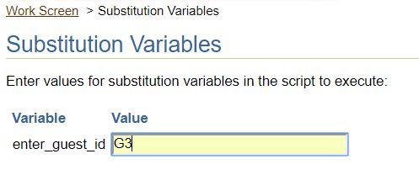

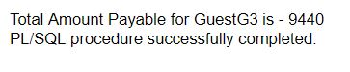

TRIGGER TO RAISE ERROR WHILE INSERTION OF INVALID SALARY

create or replace trigger t1

before insert or update of salary on employee

for each row

begin

if :new.salary<0 then

raise_application_error(-20000,'invaid salary');

end if;

end;

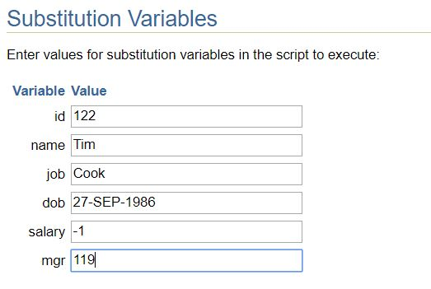

C:\Users\Chirag mahawar\Desktop\13.JPG

PL/SQL CODE TO DISPLAY MANAGER OF EACH EMPLOYEE USING SELF-JOIN

DECLARE

CURSOR c_mgr IS select e1.Eid AS EMP_ID,e1.Ename AS EMP_NAME,e2.Eid AS MGR_ID,e2.Ename AS MGR_NAME from Employee e1,Employee e2 where e1.Mgr=e2.Eid;

BEGIN

for each in c_mgr

LOOP

DBMS_OUTPUT.PUT_LINE('The Manager of '||each.EMP_ID||' , '||each.EMP_NAME||' is '||each.MGR_ID||' , '||each.MGR_NAME);

END LOOP;

END;

